Immigration: A High Calling
On this 241st birthday of the U.S.A. we think about the principles and values of our nation – what made us who we are and what shapes our moral fabric. As a nation largely made up of immigrants we recognize that at times we have oppressed people, undermined their dignity, and usurped the authority of others, most notably those for whom this is their native land. Yet on the journey of creating a culture that draws upon values and customs from people around the world, we pursue the higher ideals of God-given dignity and honor for one another as image bearers of our Creator. There are moments when as a nation we shine as a model of this high calling. And there are moments when we fall woefully short.
The WHC represents a global movement of holiness people in many nations. Although we may not be able to speak to every situation, we seek to bring God’s justice into engagement where we can. In the current discussions regarding immigration policies the U.S., we ask that elected and appointed officials seek first to honor the human dignity in every person through kindness, welcome, and commitment to the family principles that have forged our culture. While charged with the responsibility of building and protecting our nation, we urge that the fundamental Godly principles of grace and love not become secondary. May our patriotism not turn to nationalism. May our pursuit of high ideals not turn to defensive selfishness. May the immigrant always find welcome, even at the expense of our own comfort. May our commitment to law not turn to abuse. May our hearts never turn to stone but always remain soft as a reflection of God’s acceptance and love of every one of us even though we are without merit. As we pray for every nation of the world, we pray for our own -- may God bless America.
Kevin W. Mannoia
Founder & Chair
July 4, 2018

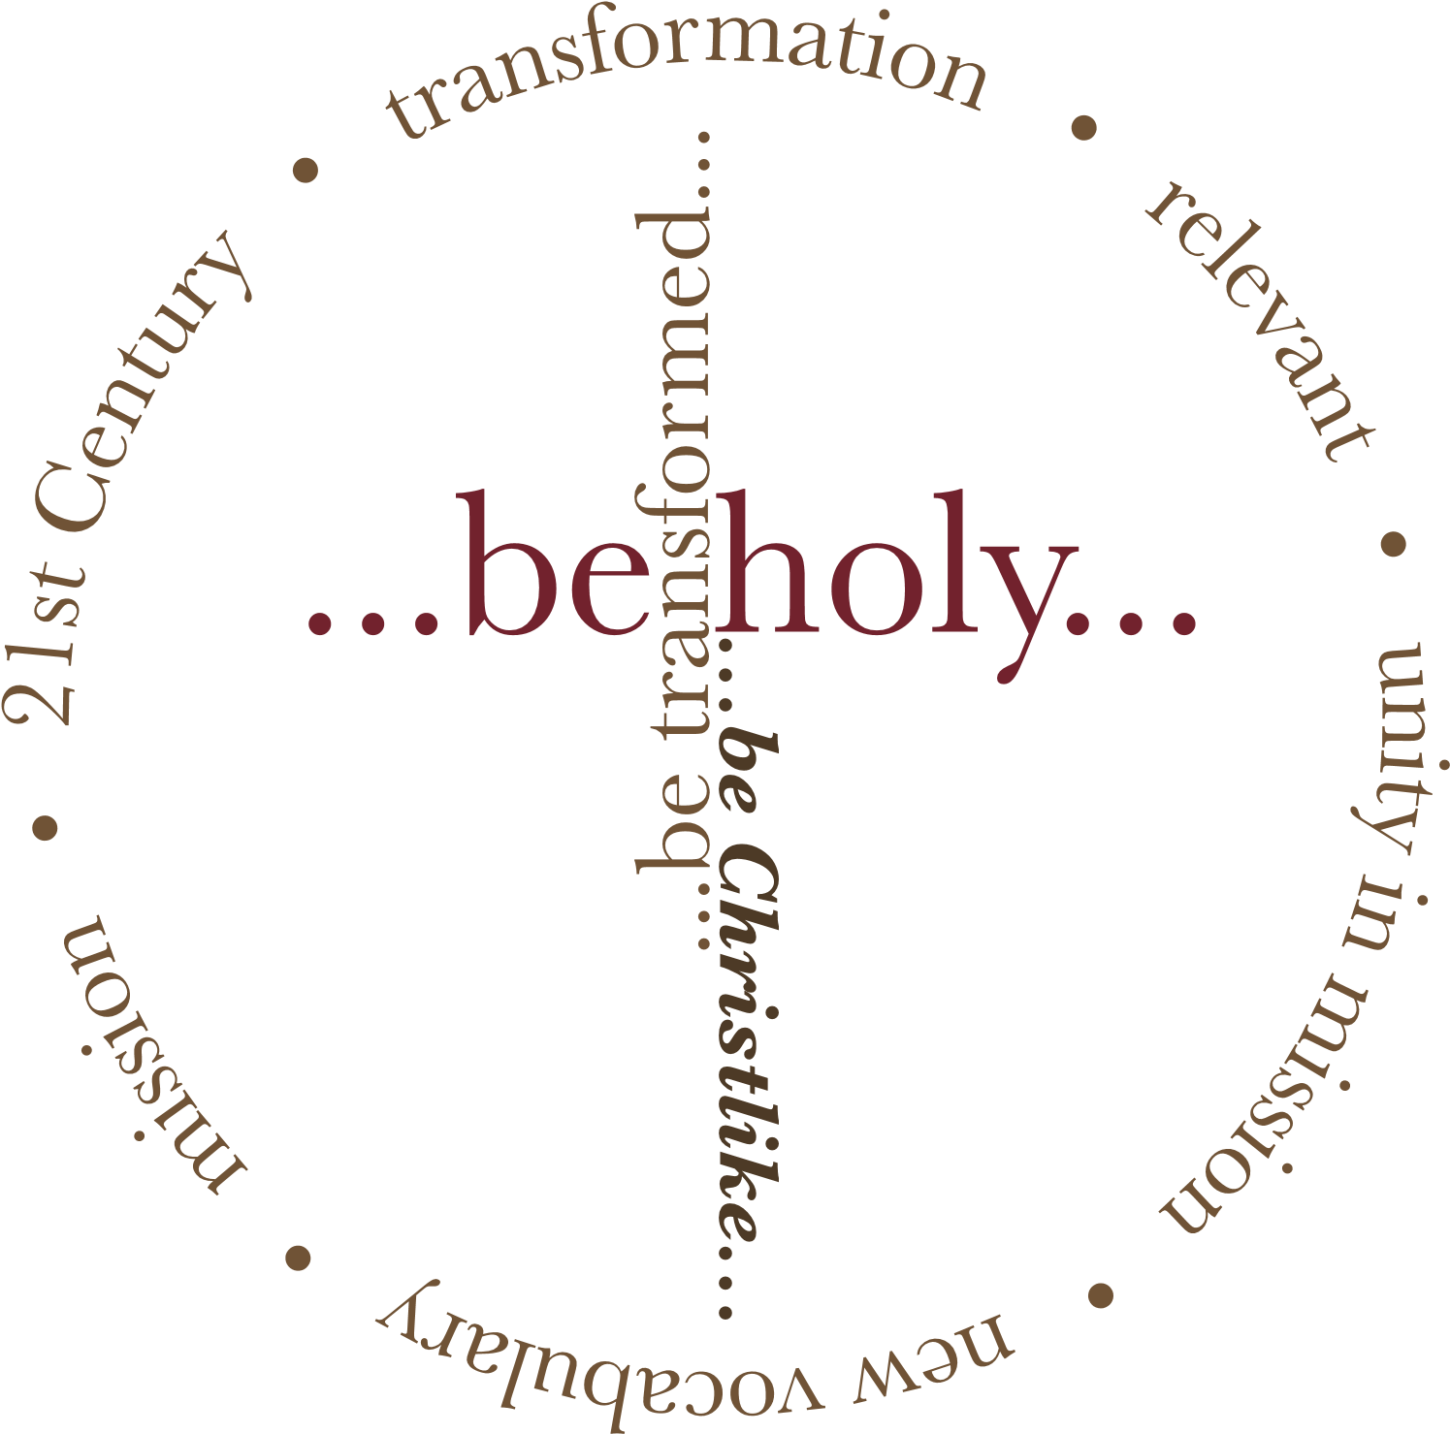
www.HolinessAndUnity.org

