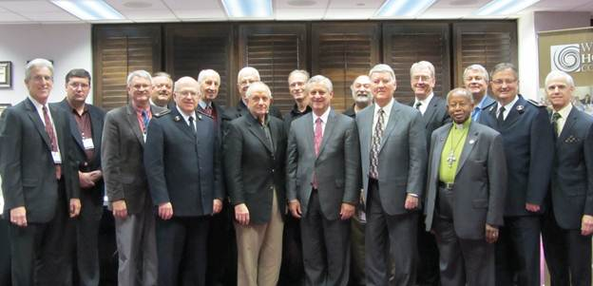

Left to Right:

Kevin Mannoia, Wesleyan Holiness Consortium

Brian Eckhardt, The Evangelical Church

David Kendall, Free Methodist

Ken Heer, Wesleyan

William Roberts, Salvation Army

Jack Hayford, Foursquare

Ronald Duncan, Church of God/Anderson

Alton Garrison, Assemblies of God

Perry Engle, Brethren in Christ

David Bernard, United Pentecostal Church International

Joseph Tkach, Grace Communion International

Vinson Synan, International Pentecostal Holiness Church

J.K. Warrick, Church of the Nazarene

Robert Smith, United Methodist

Russell Duke, Grace Communion International

James Knaggs, Salvation Army

Paul Chappell, Foursquare

Glenn Burris, Foursquare (not pictured)