PRESS RELEASE
For Immediate Release CONTACT: Kate Wallace
Wesleyan Holiness Consortium
(626) 208-5502
www.HolinessAndUnity.org
apukate@gmail.com

WHC Northwest Holiness Pastors Day – Seattle
BOTHEL, WA – On January 30, 2014 the Northwest Regional Network Holiness Pastors Day took place at Eastside Foursquare Church. Welcomed by Lloyd Moritz, Executive Director of the Pacific Northwest Association of the Church of God and Coordinator of the Regional Network in the NW area, 200 pastors gathered to discuss current issues facing the Church. These men and women represent denominations with a common heritage in the Wesleyan Holiness movement.
The morning started with a time of worship, fellowship, and prayer led by the talented Bill Anderson, Worship Arts Pastor at Marysville Church of the Nazarene.
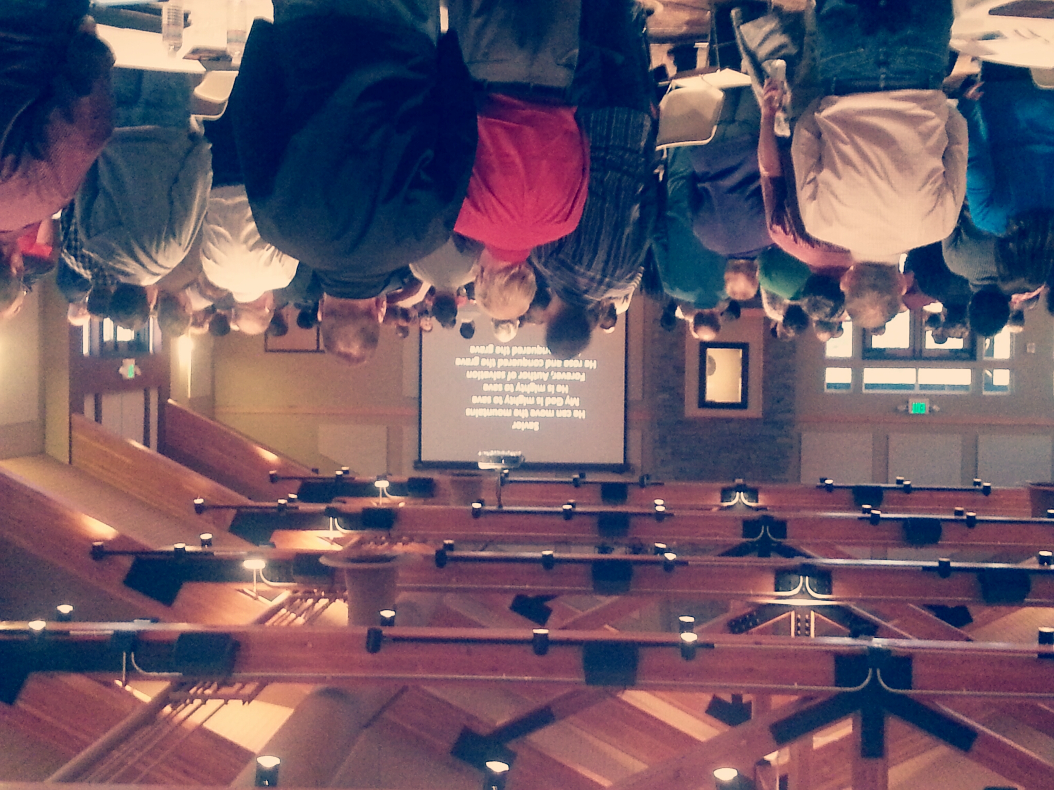
The group then had the pleasure of hearing from David Kinnaman, President of the Barna Group. Kinnaman presented the Barna Group’s research on the Millennial Generation and led the room in a discussion about how to engage with Millennials effectively in the Church. This was an extremely relevant and much appreciated conversation.
After lunch, David Kinnaman presented on the effects of technology in our culture. He brought up important issues that pastors should keep in mind when ministering to their congregants and he spoke about incorporating technology effectively into church services and ministries.
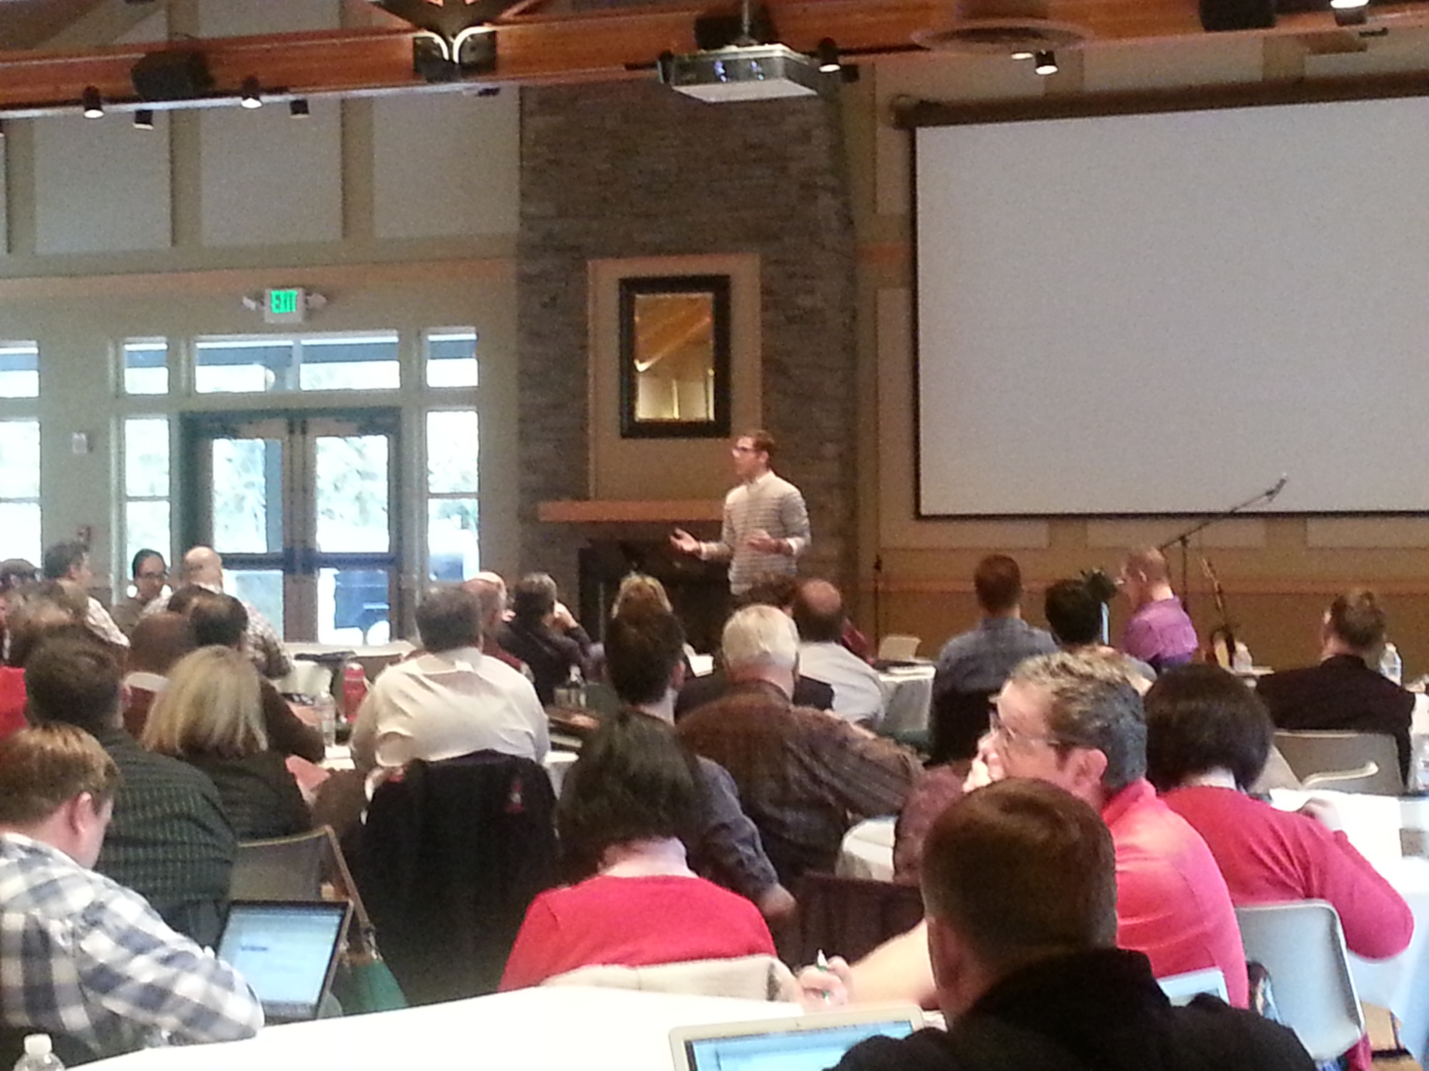
Following David Kinnaman’s presentation was a Panel Discussion with local pastors, led by Gabe Barreiro, Missional Pastor for the Northwest District of the Foursquare Church. Aldersgate Press, the Wesleyan Holiness Consortium’s publishing house, was also at the conference selling their latest releases and speaking to aspiring Wesleyan writers. The day was a great success!
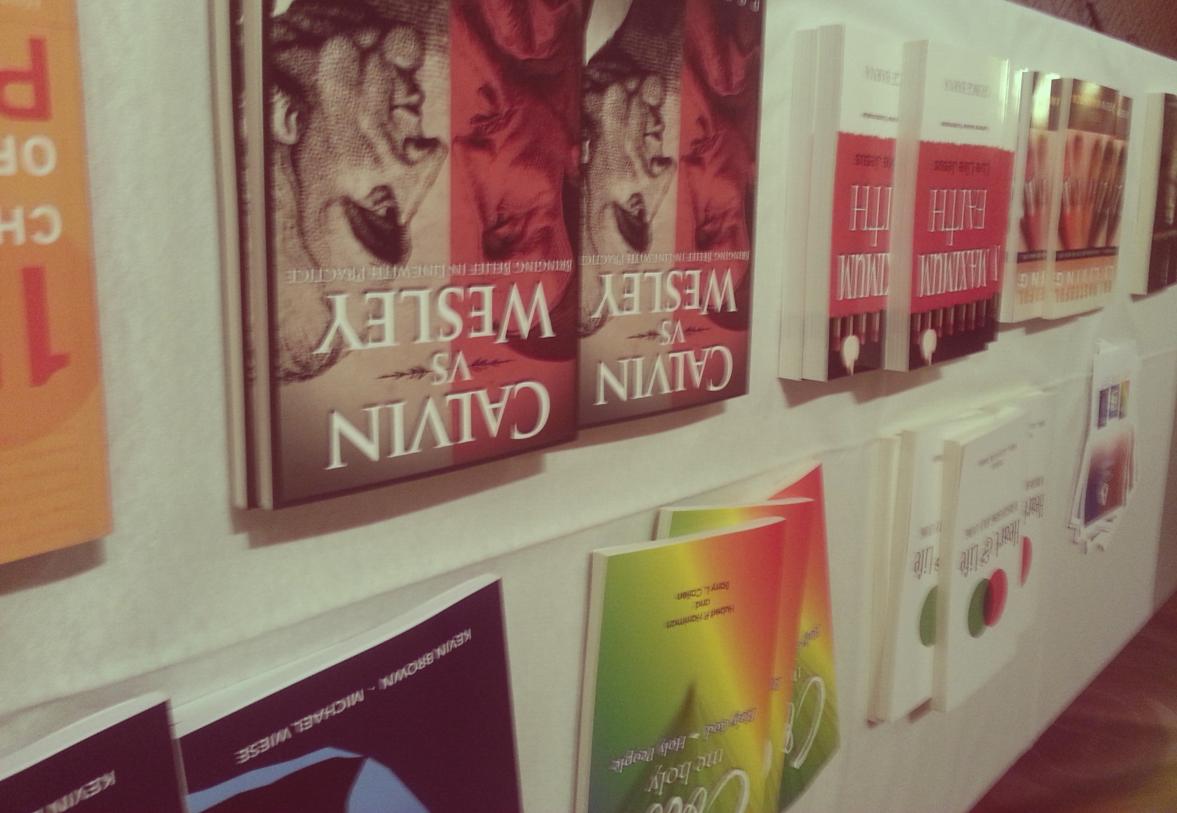

For information about the Wesleyan Holiness Consortium or any of its networks, contact the WHC offices at (626) 208-5502 or visit the web site at www.HolinessAndUnity.org.

